|  |  |
| --- | --- |
| Design Document | Email Client |
| Date | 5/8/2020 |

[Title]

Contents

1. Brief Description 4

2. Functionality 4

2.1. Folders 4

2.2. Email List 4

2.3. Email Preview 4

2.4. Functional requirement 4

2.4.1. When the app starts, the app loads the contents of each folder and displays the unread counts. 4

2.4.2. User can move around within the app to Inbox, Spam and Custom Folder 4

2.4.3. User can select any mail and look into the contents 4

2.4.4. User can see a brief preview before clicking on it. 4

2.4.5. User can delete a message. In which case it should come in deleted items 4

2.4.6. User can flag a message. 4

2.4.7. User can filter on inbox on whether a message is flagged or not. 4

2.4.8. State, navigation should be saved between refreshes 4

2.4.9. Back button should work 4

3. UI 5

4. Design approach 5

4.1. Detail Design 6

4.1.1. Header.js 6

4.1.2. App.Js 6

4.1.3. Email List 6

4.1.4. Email Preview 6

4.1.5. Folder Structure 7

Revision History

| **Date** | **Version** | **Description** | **Author** |
| --- | --- | --- | --- |
| 5/8/2020 | 0.0.1 | Design for Email Client | Vaibhav Chavan |

# Brief Description

This document contains the high-level design approach followed for creating Email client. This email client design is based on React and it is design like anss outlook kind of feature.

# Functionality

## Folders

It contains following folders which user and click and see the mail under the corresponding folder.

1. Inbox
2. Spam
3. Deleted Items
4. Custom folder

## Email List

In this email list panel we can see the listing of the email available under particular folder.

## Email Preview

In this panel preview of the selected email from email list is shown.

## Functional requirement

### When the app starts, the app loads the contents of each folder and displays the unread counts.

### User can move around within the app to Inbox, Spam and Custom Folder

### User can select any mail and look into the contents

### User can see a brief preview before clicking on it.

### User can delete a message. In which case it should come in deleted items

### User can flag a message.

### User can filter on inbox on whether a message is flagged or not.

### State, navigation should be saved between refreshes

### Back button should work

# UI

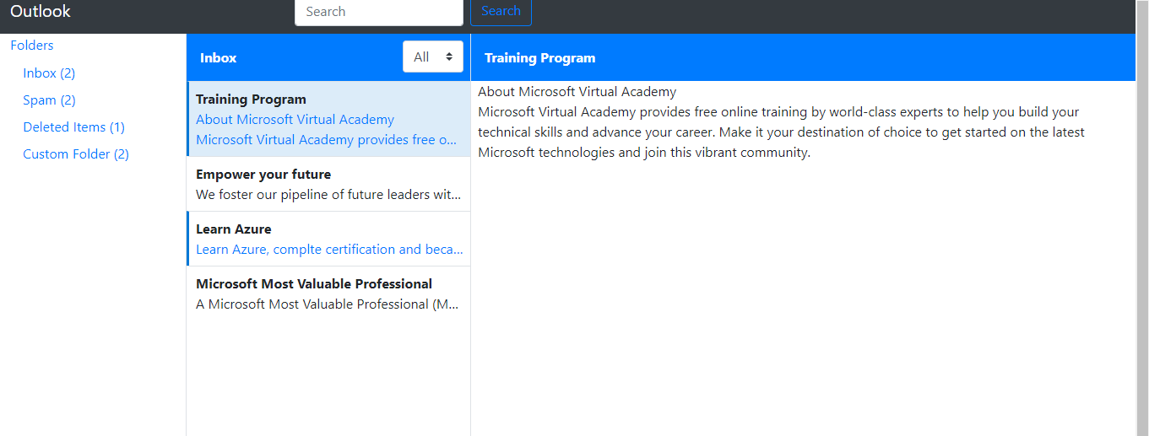

# Design approach

While designing any react application we should focus on modular approach. Whenever possible we should try to create stateless components. In this application we have created following components under common folder.

1. Header
2. Email List
3. Email Preview

In app.js we are using header component and passing data to Email List. Email list will be using all this through props and generate UI.

## Detail Design

### Header.js

In header component we have NAV bar to display search box. This is just a for presentation purpose only.

### App.Js

In app component we have our core logic. It has Accordion to display folders, onClick on any folder we call changeFolderSelection which basically set the set for folder (folder name). We have state for inbox, spam, deleteItems, custom, folder. In this component we have different functions like deleteEmail, changeUnread, changeFlag, flagFilter.

These functions gets called when we take any action like delete, flag read email etc. on Email List. We get unique Id pass to these functions, based on that Guid it mark that record a delete and update delete list, it change the status of viewed email and update correspond folder data. It uses the data for filter based on selection and update the sate accordingly.

### Email List

Email List component displays the default email using componentDidMount hook. It displays the list of email from the data pass in form of props. We attached event to different functionality in this component like delete, flag, read etc. Whenever use take any action it calls corresponding function using props. Which are handled in app component

Inside this component we are calling another component called Email Preview.

### Email Preview

This is lowest and stateless component, it is better to have stateless component from performance point of view. So as much as possible we should create component which doesn’t depend on state.

This Email Preview component will simply display the preview of the email using props.

### Folder Structure

Below is the folder structure in this application.

